Aims and objectives for the project

* **MAKE SURE TO PUT IN ETHICS FORM AT THE END OF INTERIM REPORT**
* *Research local business start-ups .*
* *Produce a business canvas model*
* *Get in contact with Bee purple and attend their events.*
* *Attend events hosted by Ride the Wave (if they are doing the program).*
* *Attend networking meetings for The Farm.*
* *Analyse competitor web design and development companies.*
* *Produce a user test to compare the usability of good and bad websites in the industry.*
* *Produce project plan.*
* **Produce a business plan.**
* *Produce website.*
* *User test for my website*
* *Optimise website using SEO.*

Outcomes and criteria of success

**Soft criteria**

Improving my entrepreneurial skills from attending: events, workshops and lectures.

Improving knowledge of the digital media sector. Mainly focused around digital design and development.

Improving my confidence by attending social networking events and workshops.

**Hard criteria**

Developing a unique brand that will encourage users to choose my services and be memorable as a brand in relation to my competitors, this will be decided after lots of market research in the website design and development industry. This can be measured by the user test I preform on a certain amount of individuals and the results gained from that test.

Once the website has been created I will be able to monitor success of it by using google analytics to check the: bounce rate, total visits and channel-specific traffic (where the user navigated to my site from).

Another aspect I will be able to measure once the website has been created is the usability. This will be done by preforming a usability test on some users, then asking them to complete certain tasks and monitoring the results. From these results I will conclude whether my website has a good usability interface or not, which I can potentially make alterations to the website in relation to the results.

Methodology

User centre iterative design process

Don’t need to write about it

I will be using an agile methodology. This methodology will work better for my business because throughout every stage it will be constantly evolving due to the information I am finding. The other methodology that I was looking at was the waterfall methodology. However this will not allow me to make large changes once certain stages are completed, resulting in a very static process.

Deliverables

* A business plan
* A business brand
* A business website

Activities

* Attending Bee purple events
* Attending a 1to1 with Bee purple
* Attending Ride the Wave events
* Attend a weekly social called The Farm.
* Produce a business canvas model
* Do user experience tests of good and bad design/development website, and create a chart from the results.
* Create and preform user test on random people to see what they think about a select few famous website design & development websites.
* Competitor analysis to help me see what is successful in the industry.
* Design and development for my business website
* Creating and preforming user tests for my website to gain feedback

Local business research

**Bee Purple** – I have signed up to Bee purple and will be regularly checking for beneficial events in Brighton. I have also organised a 1to1 with a member of their staff.

**Ride the Wave** – I have contacted Ride the Wave to see if they are continuing their program over 2015/2016 and If so check if I am able to sign up to the program. They are unsure a the moment as they are funded by Brighton and hove council, but will tell me when they find out themselves. Ride the wave hosts a series of business support events that are led by Brighton and Hove City Council. They offer workshops, networking, training and meet-ups. Their events have had great customer feedback and the satisfaction rate of them never dropped below 90%, which is great when the amount of people attending were in the hundreds.

**The Farm** – The farm is a networking group for web designers and developers located in Brighton & Hove, they meet up weekly and discuss new technologies and current news around design and development. This will be great for networking, because from the description they range from new start-up freelancers/businesses to quite successful ones.

**Wired Sussex** – I will be regularly checking Wired Sussex to see if they will be hosting any events that will be beneficial to my business.

Project Plan

Information from Liz

* CREATE A BLOG ABOUT WHAT I DO (LOG)
* Expand on this and regurgitate for final report
* Add evaluation to gantt chart (report, user test results etc)
* Business canvas model expert review
* Expert review on website (the farm etc)

Competitor analysis

**Build By Buffalo**

<http://builtbybuffalo.com/>

Build by buffalo is a Brighton based website design and development company. They have been around since 2006 and have grown drastically since then.

They have a very clean landing page that is structured nicely. There is a clear flow to the page and the user can easily navigate through the website. However if the user was to land on this page without prior knowledge about them, they might not know what type of company they are until they enter the ‘About’ section.

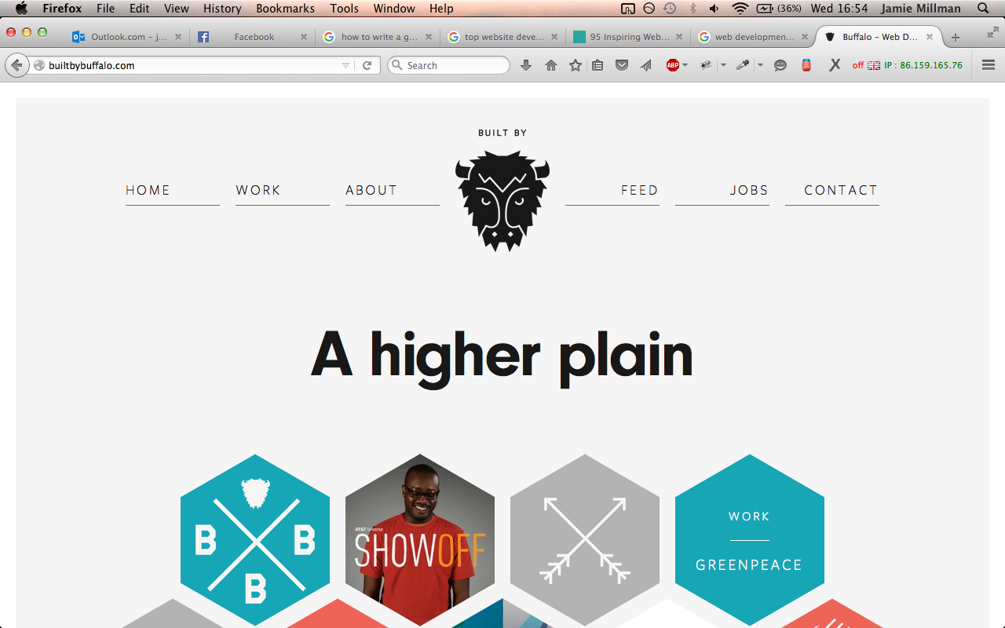

The branding of the website is minimalistic and well thought out. They use plain reoccurring colours, that are accented well with strong dominant ones throughout the whole website.

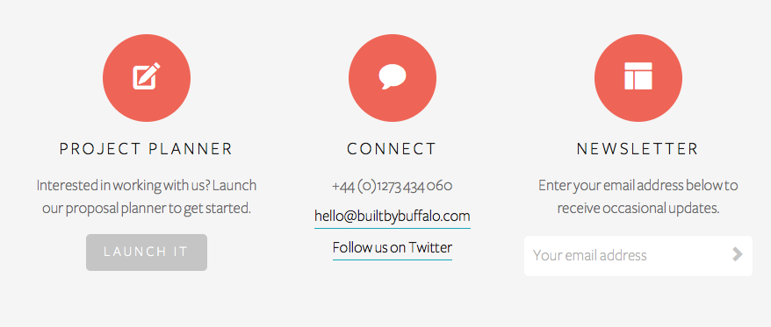

The logo is very memorable, using an image to represent part of it. This is something that will stick in users heads because the image of the buffalo can be used alone to represent the company, and it is when the website is scaled down to mobile.

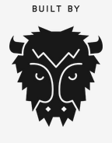 **Desktop Mobile**

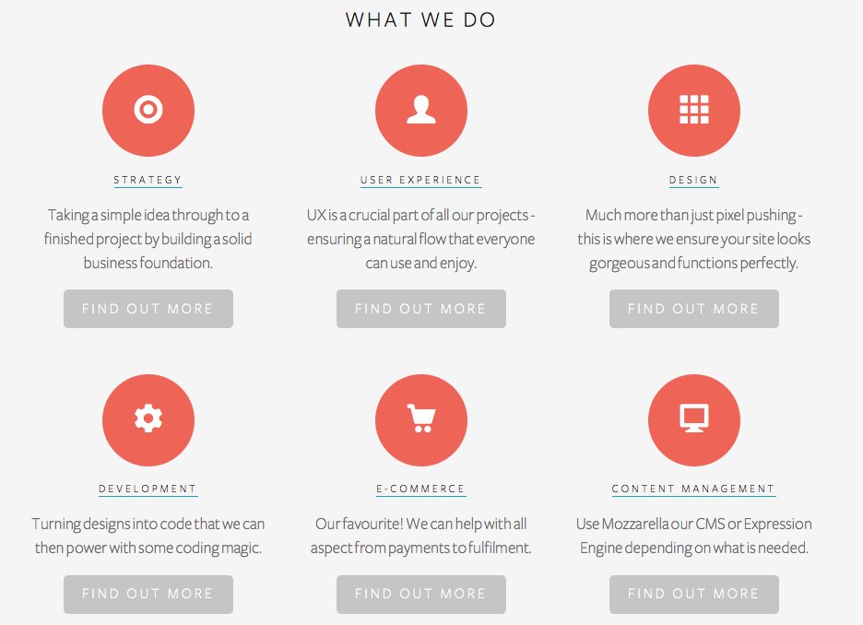The structure and content of the website is done very well. Each page, once navigated to, is clearly laid out and has a good amount of white space to allow the user to easily distinguish sections. As an example the ‘About’ section clearly labels what they can potentially work on for a client and displays it well. They have a small amount of information that really sums ups the section and once clicked can see more information.

Built by buffalo is a really well designed company that really lets the potential client see what they are able to produce with their specific skillsets.

The attitude you get from the website is the company is very laid back but also have a great professionalism about them. This gives you the sense that communication with them will be easy and enjoyable but they will achieve the goals set out.

**Code 7**

<http://www.code7.co.uk/>

Code 7 is a website design and development agency located in Brighton. Like ‘Built by buffalo’ they were created in 2007 and have grown drastically since then. Ranking 1st in Google when searching for ‘website design and development in Brighton’.

When you first land on the Code 7 home page you can see what kind of business this website is created for. I found the design quite busy, along with the lack of white space it disrupted the flow of the page resulting me being unsure what to initially focus on.

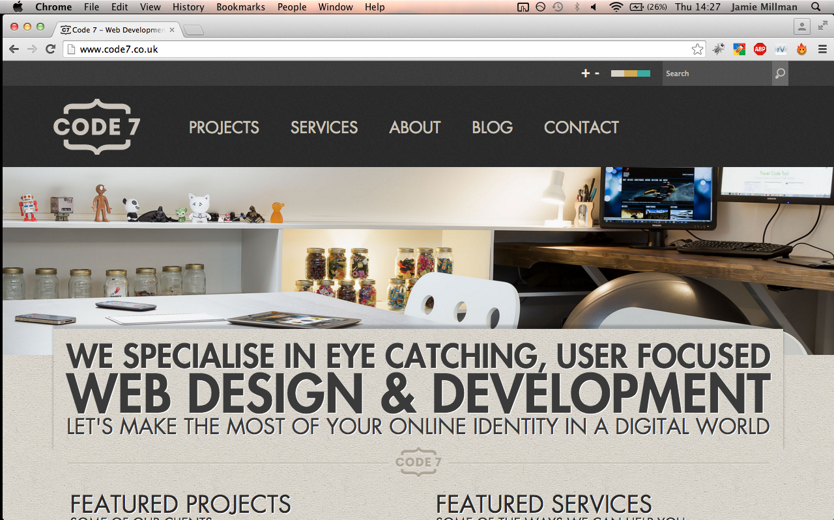(displayed on a 13” screen)

The branding of the website is quite dull. For the colour scheme they use a lot of greys and subtle colours but do not accent them with any vibrant colours. With a boring texture used as the background and no accented colours it really doesn’t make any sections stand out.

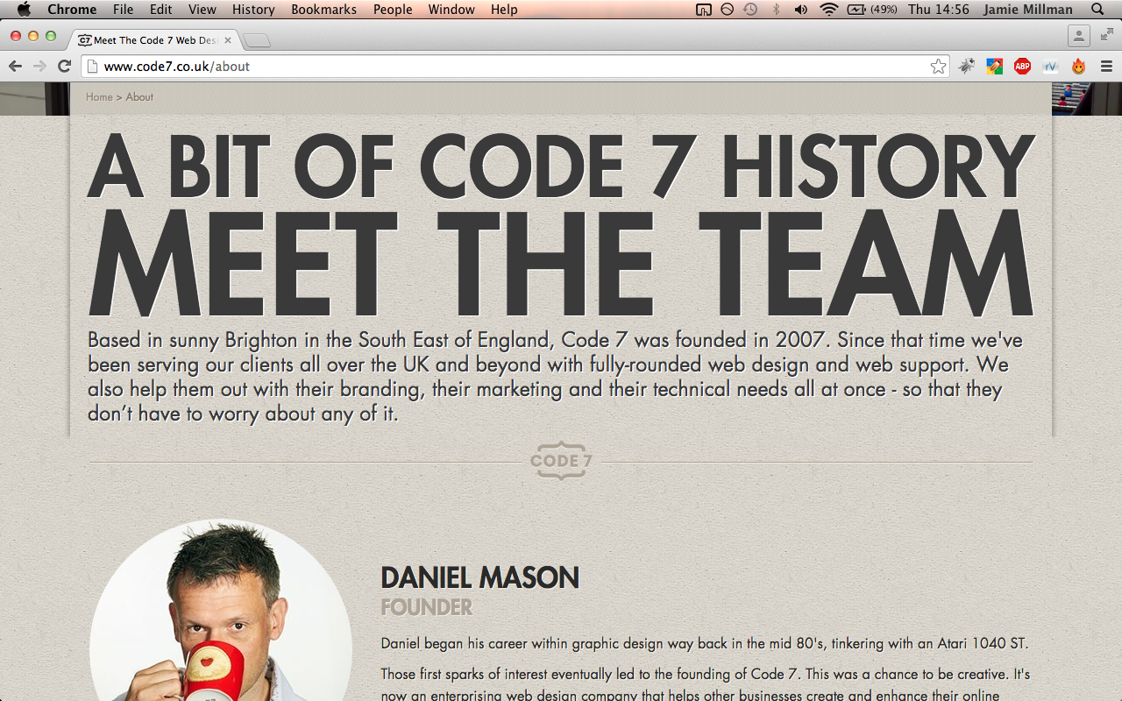

The logo is very clean and brands the website very well. It uses icons to encapsulate the title of the website nicely. This logo can be used cross platform easily, due to the short amount of text it would be able to scale nicely. This would allow it to be used in any marketing content, getting their branding seen and remembered.



Compared to Built by buffalo, Code 7 uses a lot more text on their pages. I believe this